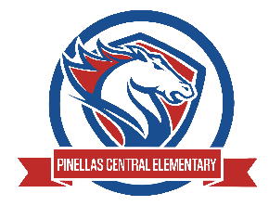

Pinellas Central Elementary School
1st Grade School Supply List 2025-2026

Abby Cannata, Principal Stephanie Wager, Asst. Principal
Student Items (for individual students use)
- 1 pair of durable headphones - not earbuds or Bluetooth
- backpack

Community Items (for classroom use)
- 2 packages of #2 yellow pencils
- 1 three prong two pocket yellow plastic folder
- 1 three prong two pocket green plastic folder
- 1 three prong two pocket blue plastic folder
- dry erase markers (black ink)
- 1 box of washable markers

Supplemental Classroom Items-Donations Welcome
- tissues
- gallon and quart sized plastic zipper bags
- antibacterial wipes
- large pink erasers
- disinfectant spray
- extra dry erase markers (black ink)
- standard sized sticky notes
- index cards
- band aids
- paper towels
- extra pair of headphones (not earbuds or Bluetooth)
- glue sticks
- class snacks (on the approved healthy list)
- Mini sticky note easel pad

